*Project:*

**Project Working Title:** e.g. Measurement of the Hall effect in amorphous films.

**Project End Date**: 10 May 2019 (The end of week 6 of spring term)

*Student:*

**Name**: e.g. Shannon Doe

**Affiliation:** Department of Physics, Oregon State University

*Biography*: write a short professional biography that includes your name, professional affiliation and something about you that you are proud of and/or that is notable. It should have a bearing on your profession, but need not be related to your research. You may include career aspirations, if you wish.

*Statement*: I will work regularly and diligently on this project throughout the year and initiate meetings with my advisor to seek feedback and guidance on the research. I understand that a significant portion of the research should be completed by the end of winter term to enable me focus on the writing process in the PH403 class.

Student Signature: _____________________________

*Advisor:*

**Name** e.g. Prof. Janet Tate

**Affiliation** e.g. Department of Physics, Oregon State University

I have read this thesis proposal. I agree that the scope is reasonable for completion by May 10, 2019 and that sufficient progress can be made by early winter term 2019 to allow significant revision of the thesis during the winter and spring terms of 2019.

Advisor Signature*:* _____________________________

**Project Summary**

Give an executive summary of the proposed project with no introduction, background, etc. Focus on YOUR work (not the history or the community view). What will you study? How will you study it? Why is it interesting?

**Project Description**

*Introduction*

Set the context and motivation for your work. This might include a brief overview of previous work in your group and the field in general to show why the proposed work is interesting. The basic principles that underpin your work should be explained. Please **include a figure** or two. A simple hand-drawn schematic can be indispensable. Labels on the figure are sized to match the main text.

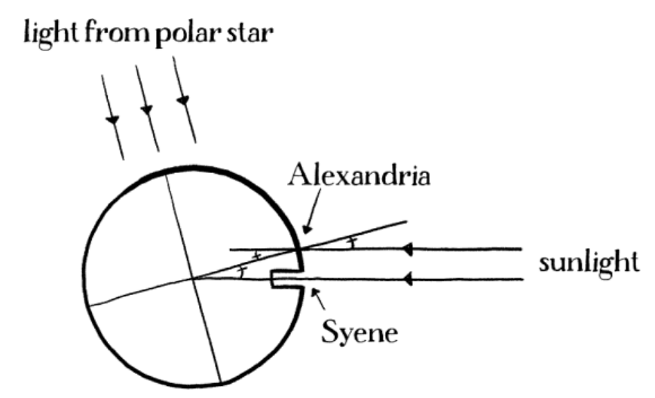

Figure 1. Eratosthenes devised the first method to determine the size of the Earth. When Sunlight reaches the bottom of a well in Syene, the same light makes a 7 degree angle relative to a vertical pole in Alexandria. Figure credit: “Drawing Physics” by D.S. Lemons.

*Plan of work*

The project description contains a clear statement of work and should include objectives. Outline the general plan including the broad activities to be undertaken, a clear description of experimental and/or theoretical methods & procedures. What do you plan to do, why do you want to do it, how will you do it and how will you know when you have succeeded? **Include figures** as appropriate, and it will be very unusual if there are none. Preliminary data/results are not required, but if you have them, include them because it will explain where you are in the process. Are collaborators involved in your work? If so, describe their roles.

*Timeline*

Include a timeline for the research work (experimentation, computation, data analysis, *etc*. as appropriate), literature review and writing. Writing should be in parallel with the research, not after it. This paragraph shows that you have given thought to planning the work, and that you are aware of the importance of time management. If you have completed a portion of the work, that's fine, simply make clear what has been done and what is left to do.

*Data management*

Plan for data management (1-2 paragraphs). This paragraph shows that you understand that your data and samples must be appropriately recorded and stored. If you are computationalist, you may generate large amounts of data, so digital storage may need special consideration.

*Facilities, Equipment and Other Resources*

What equipment, samples, computers, etc. do you need and who will provide them? Here you will demonstrate that you understand the scope of your work, the extent to which you may have to rely on collaborators, and scheduling of time on specialized equipment, among other things.

**References Cited**

At least 4 or 5, including a review article. References must be in appropriate scientific format and must include the title of the article.

**Format**

Text must be in single column format with 1-inch margins. Use double spacing between lines of text (this helps the peer review process). Use 11- or 12-point Arial, Times, Times New Roman or Cambria fonts. There is a 8-page maximum, excluding the coversheet. Number the pages.